# Lecture 26. Root Access to AWS Services 1:44

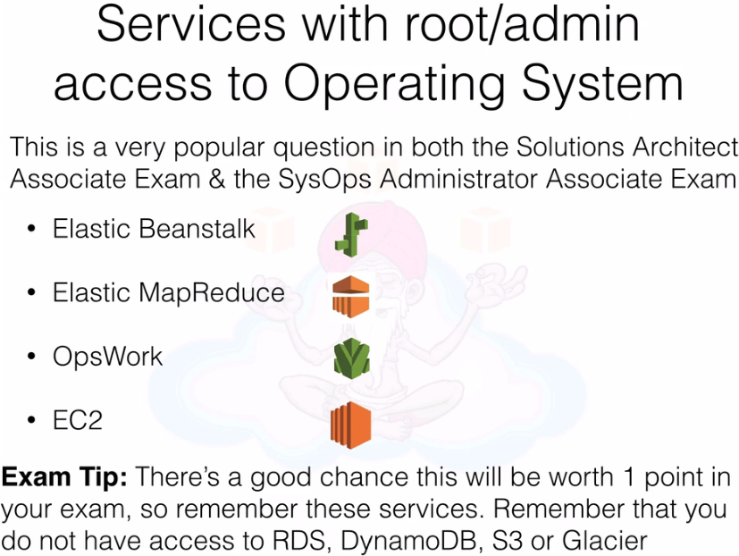

# Lecture 27. Elastic Load Balancer Configurations 14:38

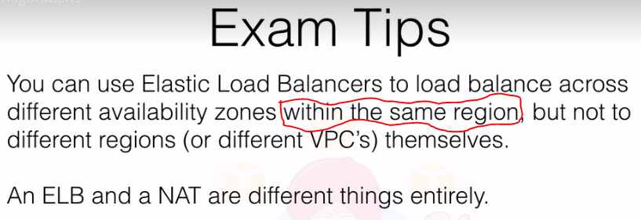

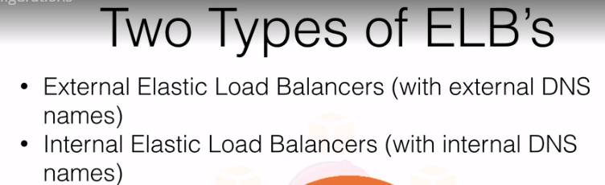

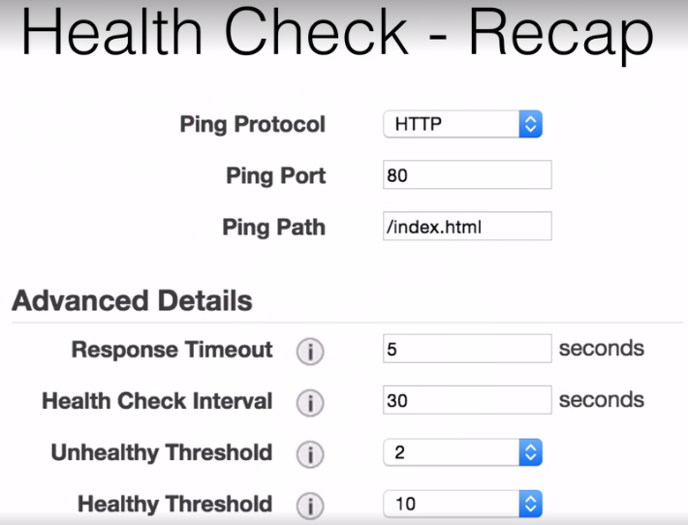

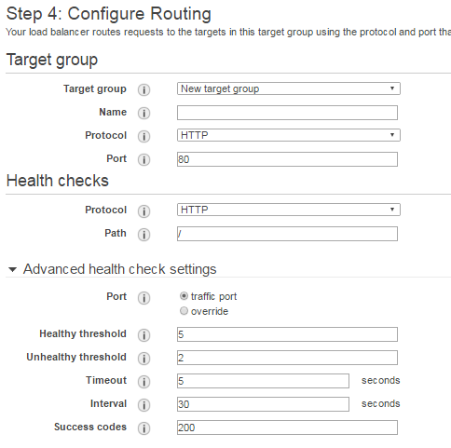

|  |  |
| --- | --- |
| Protocol | The protocol the load balancer uses when performing health checks on targets in this target group. |
| Path | The destination path for health checks. This path must begin with a '/' character, and can be at most 1024 characters in length. |
| Port | The port the load balancer uses when performing health checks on targets. The default is the port on which each target receives traffic from the load balancer, but you can specify a different port. |
| Healthy threshold | The number of consecutive health checks successes required before considering an unhealthy target healthy (2-10). |
| Unhealthy threshold | The number of consecutive health check failures required before considering a target unhealthy (2-10). |
| Timeout | The amount of time, in seconds, during which no response means a failed health check (2-60 seconds) |
| Interval | Amount of time between health checks (5 sec - 300 sec). |
| Success Codes | The HTTP codes to use when checking for a successful response from a target. You can specify multiple values (for example, "200,202") or a range of values (for example, "200-299"). |

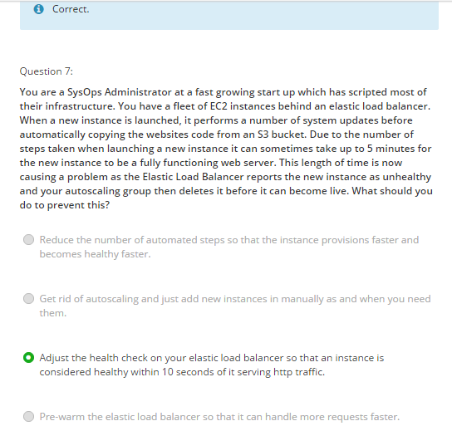

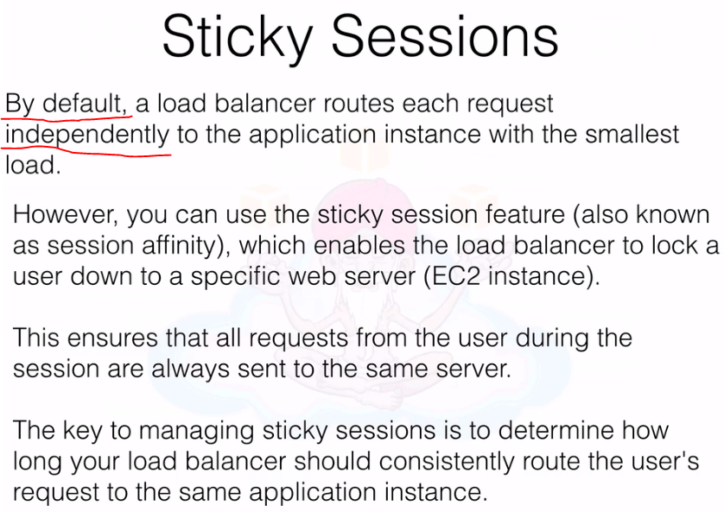



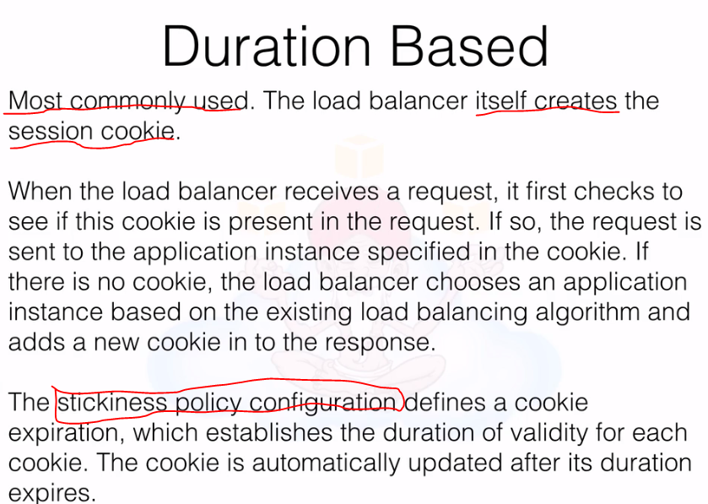



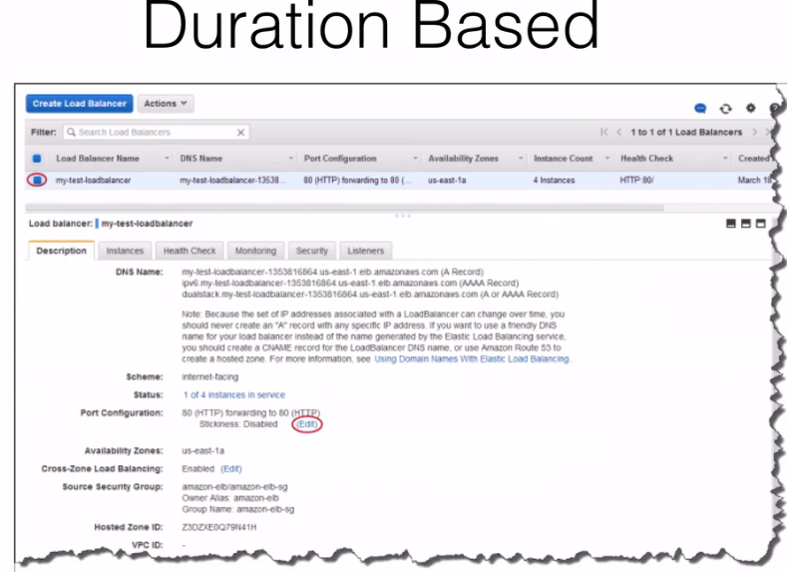

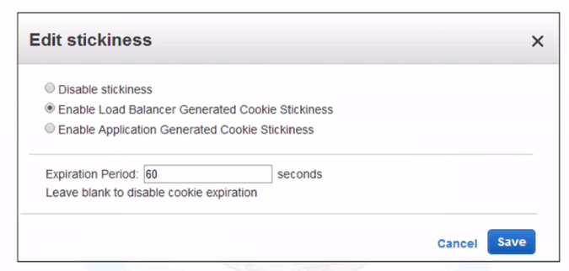

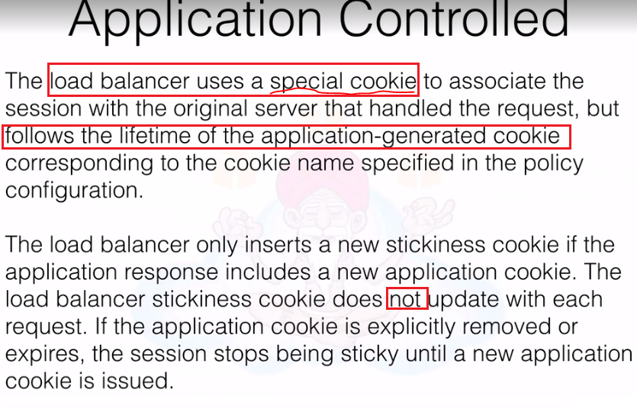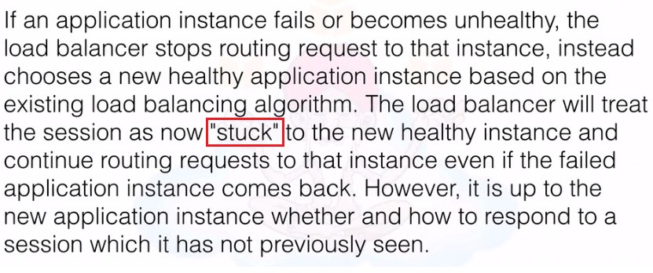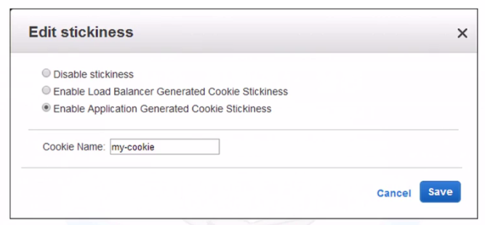

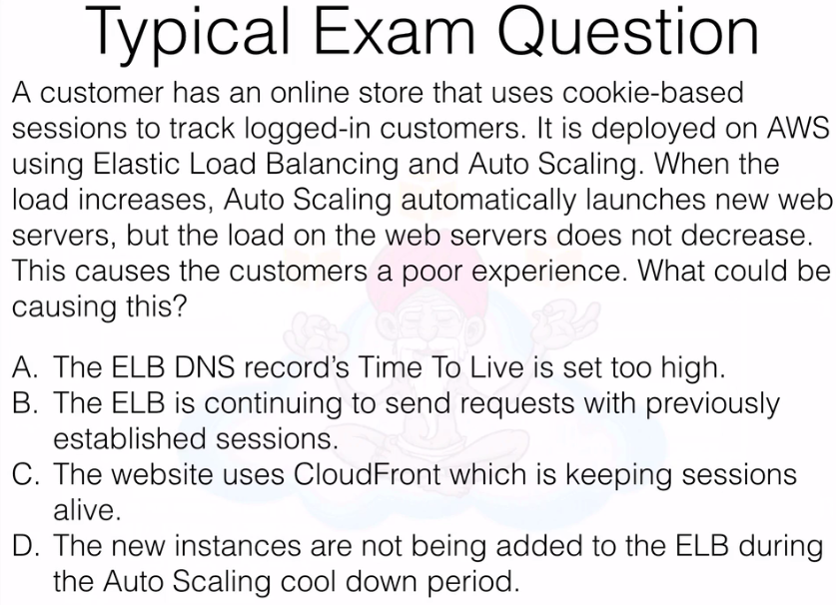

Ans: B (As it’s possible that Sticky Session Timeout is more, may be 20 mins. In this case request will still be on original instances).

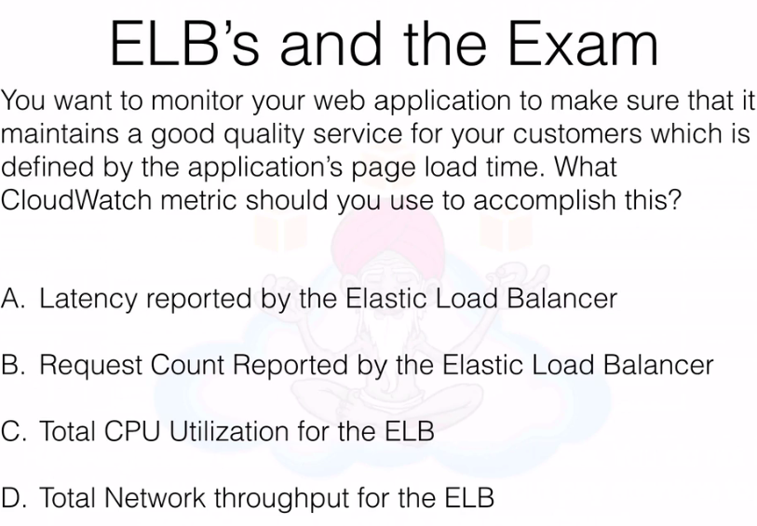

Ans : A

# Lecture 28. Pre-warming - Elastic Load Balancers 2:10

